The United States Patent and Trademark Office

Leading the World in Intellectual Property
Protection and Policy

Strategic Plan -- 2007-2012

D R A F T #6
August 21, 2006

STRATEGIC PLAN 2007-2012
Table of Contents

UNDER SECRETARY AND DIRECTOR’S LETTER………………………… | TBD
USPTO’s STRATEGIC FRAMEWORK ………………………….…………… | i
INTRODUCTION……………………………………………………………….. | 1
Changing Times Require a New Focus ………………………………………….. | 1
Who We Are……………………………………………………………………… | 4
Background……………………………………………………………………….. | 6
Our Challenges/Opportunities………………………………………………… | 7
Planning Assumptions/Critical Needs…………………………………………. | 9
Goal 1 Optimize Patent Quality and Timeliness
Accomplishments for 2005/2006…………………………………………………. | 11
Introduction………………………………………………………………………. | 11
Challenges/Opportunities………………………………………………………… | 12
Strategic Response………………………………………………………………...  Objectives/Initiatives/Planned Accomplishments and Results | 18
Goal 2 Optimize Trademark Quality and Timeliness
Accomplishments for 2005/2006…………………………………………………. | 21
Introduction ……………………………………………………………………… | 21
Challenges/Opportunities………………………………………………………… | 21
Strategic Response………………………………………………………………...  Objectives/Initiatives/Planned Accomplishments and Results | 23
Goal 3 Improve Intellectual Property Protection and Enforcement Domestically and Abroad
Accomplishments for 2005/2006………………………………………………… | 28
Introduction…… ……………………………………………………………….... | 29
Challenges/Opportunities………………………………………………………… | 29
Strategic Response………………………………………………………………...  Objectives/Initiatives/Planned Accomplishments and Results | 30
Management Goal Achieve Organizational Excellence
Accomplishments for 2005/2006…………………………………………………. | 34
Introduction…………………………………………………………….…………. | 34
Challenges/Opportunities………………………………………………………… | 35
Strategic Response………………………………………………………………...  Objectives/Initiatives/Planned Accomplishments and Results | 35
Appendix A – Acronyms/Definitions…………………………………….………. | TBD
Appendix B – Strategic Planning Process………………………………………… | TBD
Appendix C – Update to 21st Century Strategic Plan Initiatives…………………. | TBD
Appendix D – Workload and Performance ……………………………………… | TBD
Appendix E – Program Evaluations……………………………………………… | TBD
[Note: Appendices will be reordered and identified in the narrative in the next version of the document.]

UNDER SECRETARY AND DIRECTOR’S LETTER -- TBD

USPTO’S STRATEGIC FRAMEWORK

MISSION
To foster innovation and competitiveness by:
Providing high quality and timely examination of patent and trademark applications,
Guiding domestic and international intellectual property policy, and
Delivering intellectual property information and education worldwide.

VISION
USPTO: Leading the World in Intellectual Property Protection

Strategic Goals

Optimize Patent Quality and Timeliness

Optimize Trademark Quality and Timeliness

Improve Intellectual Property (IP) Protection and Enforcement
Domestically and Abroad

Management Goal and Objectives

Achieve Organizational Excellence by: Enhancing a culture of high performance and becoming the employer-of-choice, and Ensuring responsible management of resources

Guiding Principles

Certainty + Cost-Effectiveness + Accessibility = Quality

i

INTRODUCTION

Changing Times Require a New Focus

Since the introduction of the 21st Century Strategic Plan in 2002, USPTO has dramatically changed its work environment. Both patent and trademark searches are conducted using electronic tools. Processing of patent and trademark applications has transitioned from paper to computer, administrative law hearings are conducted via videoconference, speeches are web cast, and e-mail is a fact of business life. An important and increasing percentage of USPTO employees work from their homes. Patent and trademark applicants use USPTO Internet website to file, track their applications, write to the Office, search, research, and keep up with USPTO news. Users around the globe rely on the USPTO’s employees and systems for their intellectual property (IP) news, information, and rights.

In this new, more electronic environment, communications with and among employees, as well as reliability of our electronic systems are in focus as never before. In order to ensure that Americans reap every possible benefit from IP rights, the USPTO must be accessible, efficient, and effective

The primary responsibilities of the USPTO relate to the grant and issuance of patents and the registration of trademarks, and, the public dissemination of information relating to those patents and trademarks. These responsibilities are executed by the Under Secretary and Director of the USPTO, in the capacity of Director. The USPTO also advises the Administration on national and international intellectual property policy issues and other Federal departments and agencies and international intergovernmental organizations on matters of national and international intellectual property policy and intellectual property protection in other countries. These latter responsibilities are executed by the Under Secretary and Director of the USPTO, in the capacity of Under Secretary.

These responsibilities are varied and wide-ranging, demanding effective execution to support and promote the IP system of the United States, in accordance with the Constitutional objectives of our system, and to ensure that international and foreign intellectual property systems are similarly focused.

More directly, the USPTO examines patent and trademark applications. We also manage programs to educate and promote awareness of intellectual property, both in the United States and internationally; train judges, prosecutors and other IP officials, provide IP policy input and guidance to the Administration, help regulate patent practitioners, participate in bilateral and multilateral negotiations, develop and promote internationally “best practices” for IP, and ensure that users of USPTO services receive value for their time and money.

Given these varied responsibilities, what principles inform and guide our strategic thinking? Our guiding principles are very clearly:

- Quality – of which timeliness and accuracy are key components, and which also requires good processes, good inputs, and great people.
- Certainty – which implies consistency, predictability, and accuracy;
- Cost-Effectiveness – which implies efficiency, measurements, and delivery standards; and
- Accessibility – which requires impartiality and fairness, as well as a customer-service mentality.

How do these guiding principles relate to our strategic planning and implementation?

Quality must permeate every activity, product and service provided by the USPTO. While the quality of our patent and trademark examination must necessarily be at the forefront, it is not sufficient – or even possible – to have quality examination without high-quality data and support. Thus, our new strategic plan identifies measures to enhance the quality of every input and action in our patent and trademark process -- from the information we receive from applicants, to the administrative support we provide our own employees.

Strategically, USPTO's primary emphasis is quality. For patents and trademarks, quality means timely, consistent, accurate examination. How do we achieve timely, consistent, accurate examination? Via streamlined procedures, good inputs, and great people.

USPTO’s various proposed rules changes for patents, which were published in 2006, are aimed at improving inputs. Establishment, in 2005, of the Central Reexamination Unit, pre-appeal brief conferences, and other internal improvements are steps we have already taken to streamline USPTO procedures.

With respect to great people, USPTO’s goal is to attract and retain the best. How will we accomplish this? We must be open to the possibility that permitting examiners to live and work somewhere other than the National Capital region will help USPTO attract and retain the best. Our strategic plan does not predetermine an answer to the question “How do we attract and retain great people?” Rather, it identifies the strategic goal of attracting and retaining the best, and suggests initiatives that will best focus the USPTO on achieving this critical goal.

Exploring alternate work locations, nation-wide work@home, and other options, are therefore mentioned as strategic initiatives that may help USPTO attract and retain the best.

The formula for Certainty includes good communications so that we have consistency. It includes a capable workforce so that we have accuracy. It includes fully integrated supporting systems and uniform data to ensure reliability.

A capable workforce – our employees – is the single most critical component to achieving our goals.

Without capable people, we will fail. Therefore, our new strategic plan focuses heavily on people: how to attract capable employees to the USPTO; how to train our workforce for existing and upcoming conditions; how to retain our employees; and how to make the USPTO the best place to work.

Cost-effectiveness requires commitment to delivery standards, milestones, employees capable of and dedicated to responsible contract and project management, as well as the ability to plan – not merely on a fiscal-year basis, but on a strategic, out-year basis. USPTO must take the long view, as well as the annual view if it is to be a responsible steward of both funds and systems.

To achieve cost-effectiveness, our new strategic plan identifies concrete actions, including implementation of internal Service Level Agreements (SLAs) that form the basis of specific, measurable delivery standards incorporated into employees’ Performance Appraisal Plans (PAPs).

Accessibility means that USPTO’s practices and services are transparent, reliable, and available as much as possible. Accessibility may mean, for some systems, that they are available twenty-four hours per day, every day of the year.

The USPTO has done much over the past several years to enhance the accessibility of its information and people. Our significant efforts to provide electronic filing via the Internet, the availability of patent and trademark-file contents via the Internet, to permit communication via e-mail, as well as to provide as much training and research material as possible via www.uspto.gov opens the USPTO to the public in an historic manner.

Realizing that independent inventors, small businesses, and America’s youth require and deserve special attention from the USPTO, our new strategic plan emphasizes revitalized programs, training materials and outreach efforts specially tailored to meet the needs of America’s current and future entrepreneurs and inventors.

Effectiveness means that USPTO fulfills its manifold responsibilities in the best way possible. We believe that a dedication to quality, certainty, cost-effectiveness and accessibility will ensure that the USPTO is effective.

In summary, certainty, cost-effectiveness, and accessibility are essential components of quality. This strategic plan is dedicated to bringing Americans – and the world – the platinum standard of quality in everything we do.

Who We Are

The United States Patent and Trademark Office (USPTO) is the Federal agency responsible for granting U. S. patents and registering trademarks. In doing this, the USPTO executes Article I, Section 8, Clause 8 of the Constitution “to promote the progress of science and useful arts, by securing for limited times to authors and inventors the exclusive right to their respective writings and discoveries.” This responsibility was expanded in the 19th century when the commissioner of patents was given the authority to register trademarks, based on the “commerce” clause of the Constitution (Article 1, Section 8, Clause 3).

The USPTO examines patent and trademark applications, grants patents, registers trademarks, and disseminates information relating to those patents and trademarks. Central to this operation is our function as a quasi-judicial federal agency, which makes decisions on rights in intellectual property. In reorganizing the agency in 1999 to give it greater management responsibility over its fee-funded operations, Congress established a system for holding the agency responsible for granting or recognizing intellectual property rights and for protecting the public domain. It accomplishes both by making prompt and legally correct decision. We also have an essential role in the commerce of the country by providing information on patents and trademarks.

The USPTO advises the Administration on national and international intellectual property policy issues. The Office also advises other Federal departments and agencies and international intergovernmental organizations on matters of national and international intellectual property policy and intellectual property protection in other countries.

The USPTO is headquartered in Alexandria, Virginia. The USPTO’s Internet address is http://www.uspto.gov

- The USPTO has over 8,000 employees.

U. S. Patent and Trademark Office
Organization Chart

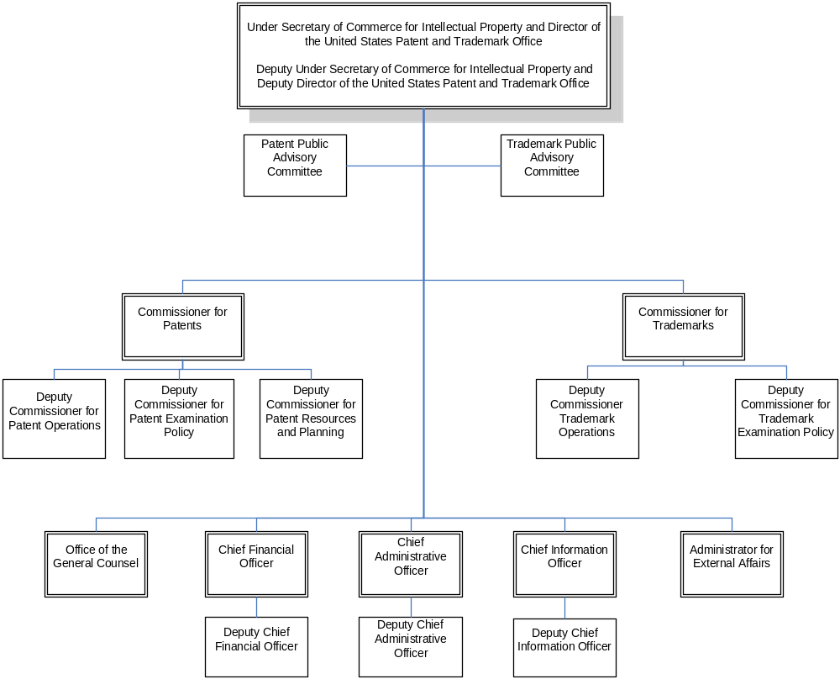

Background

In charting the U.S. Patent and Trademark Office’s (USPTO) work over the next several years, this Plan takes into account the forces that are likely to shape Intellectual Property Rights (IPRs) in the United States and throughout the world. As represented by the model below, our strategic planning encompassed an end-to-end examination of all components of our core responsibilities.

INPUTS
ACTIVITIES

OUTPUTS
OUTCOME/IMPACT

- Influences  - Customers  - Funding  - Employees  - Laws  - Regulations  - Patent and Trademark Applications  - Research and Development  - Industry and Business Activities |  | - Examination  - Appeals and Oppositions  - Dissemination  - Support Services  - Application Management  - Patent Cooperation Treaty Applications  - Classification System  - Publication  - Policy-making |  | - Patent Grants  - Trademark Registrations  - Denials of Unmeritorious Applications  - Products  - Public Search Facilities  - U.S.Government/USPTO Positions and Proposals |  | - Intellectual Property (IP) Protection  - Protection of Investment in the U.S. and Internationally  - Competitiveness  - New Products in the Marketplace  - Innovation  - Economic Growth
The USPTO submitted its 21st Century Strategic Plan and implementing fee legislation to Congress in June, 2002, updated the Plan in response to stakeholder input in February 2003, and has followed that Plan over the past four years. The aggressive and far-reaching 21st Century Strategic Plan committed us to:
- Promote the intellectual property systems of the future to keep American innovators competitive in the global economy, and
- Transform the agency into a quality-focused, highly productive and responsive organization.

Since that time, the USPTO delivered on key strategic promises to:

- Make quality the number one priority – for example, we increased the competencies of our employees and enhanced our patent and trademark quality assurance programs.
- Move toward full patent and trademark electronic processing -- for example, electronic processing of patent applications was implemented in August 2004.
- Protect the U.S. IP system and American interests internationally – for example, we implemented the Madrid Protocol in November 2003.
- End fee diversion and receive Congressional approval of a new fee structure – for example, legislation was put in place for fiscal years 2005 and 2006.

We now need to build on this solid infrastructure for the future by:

- Taking innovative steps to address pendency and patent backlogs by hiring, training and allowing employees to work at home or offsite.
- Continuing to enhance the quality of the search and examination processes.
- Completing the transition to electronic filing and processing of patent and trademark applications.
- Securing long-term funding authority to enable us to deliver on performance commitments, respond to demands for service, fluctuations in filings, and set fees that better reflect cost of service.

Our Challenges/Opportunities

Despite successes and accomplishments, the Office still faces on-going challenges related to complex patent laws and rules, fluctuations in filings, increasing complexity and volume of patent applications, continuing questions about the quality of examination, the transition to operating in a fully electronic environment, the impact of counterfeiting and piracy on American business interests in the United States and throughout the world, and securing appropriate resource levels and operational flexibilities.

- The increasing number and technical complexity of patent applications, coupled with the ability to hire new and replacement patent examiners, continues to challenge the USPTO. The rate at which patent applications are being filed has increased beyond the rate at which we are currently able to examine patent applications, resulting in an increasing backlog awaiting examination that could approach one million cases by 2010 without significant changes. Patent pendency now averages more than 30 months and is expected to increase to 33.8 months (to issue) in 2011. Our challenge is to move toward a patent system that consistently meets the needs of applicants and the public, and enables the USPTO to issue quality patents in a timely manner.

- Optimizing patent and trademark quality will provide more consistent results and certainty for applicants, registrants and patent owners. Our challenge is to maintain quality as our highest priority and demonstrate, through statistically valid metrics, that the quality of our work is the highest possible commensurate with the given level of resources.

- Operating in today’s domestic and international environment requires us to have full electronic processing that is safe, secure and continually available to employees, applicants and stakeholders. Additionally, electronic filing and communication tools must be developed that are compatible with tools developed by other major IP Offices and those used in the offices of our applicants.

- In an increasingly globalized business environment, the current model of national and regional intellectual property systems does not meet the needs of today's innovators, creators and businesses. Our challenge is to work with other IP Offices on harmonization efforts in order to streamline our laws and practices and create better functioning intellectual property systems for all.

- As counterfeiting and piracy continue to undermine global trade, the U.S. Government must double its efforts to ensure that substantive IP rights are effectively and adequately protected and enforced throughout the world.

Our intellectual property system has been, since the founding of the United States, an integral and critical part of what makes America great. The numbers tell the story. “U.S. intellectual property today is worth between $5 trillion and $5.5 trillion, equivalent to about 45 percent of U.S. GDP and greater than the GDP of any other nation in the world.”

Furthermore, consider these statistics:

- U.S. IP Industries contribute “nearly 40% of the growth achieved by all U.S. private industry and nearly 60% of the growth of U.S. exportable products and services.”
- “GDP 10-year growth estimates would be approximately 30% lower than current predictions without the contributions of these [IP] industries”
- U.S. IP industries represent 18 million workers who earn an average 40% more than all U.S. workers.
- In 2003, the core copyright industries contributed $33 billion in reported net export revenues
- In 2004, the patent-dependent aerospace industry reported net export revenues of $32 billion.

- American businesses, inventors, educational institutions, students and foreign officials need to be better informed of the benefits, and effective use, of IP. The challenge for the Office is to craft and deliver an effective educational program and expand access to information.

- The Office has special challenges as a fee-funded organization. We must accurately project likely activity (such as application filings) in order to assure that fee receipts cover the cost of operations. We must project future-year demands for our services in order to train and retain a staff capable of meeting these demands in a quality and timely manner. Though held accountable for business-like efficiencies in performance, we face obstacles that many business firms do not face. We are subject to both the vagaries of demand for our services, and the availability of sufficient operating funds. Further, operating under annual appropriation of funds makes it difficult to assure adequate investment to meet demands for our services. In this regard, we must make optimal use of “no-year” appropriations, which may give us flexibility to accelerate or delay certain investment decisions, while assuring that exercising such discretion does not lead appropriators or stakeholders to faulty conclusions about the cost of operations. For the future, the USPTO plans to work with the Administration to explore options, which would enable us to borrow and invest funds.

- Moreover, unlike businesses, we are subject to government personnel rules, which at times restricts our ability to quickly respond to changing workloads and hire the number and type of employees who can deliver the services our applicants and others expect from us. Therefore, the USPTO must use the most effective personnel practices, technologies, flexibilities and management techniques to continually maintain and develop an appropriately sized, skilled and diverse staff that is genuinely committed to delivering our important patent and trademark services to the American people.

- Organizational health is directly related to effective communication – communication between employees and our external community, and communication with and among employees. The challenge is to enhance communications at every level of the organization.

Planning Assumptions/Critical Needs

This Plan is predicated on a number of Planning Assumptions/Critical Needs:

- Patent application filings will increase by XX percent through 2012.
- Trademark application filings will increase by 6 to 8 percent each year through 2012.
- The fee structure and changes to practice that were temporarily put in place for fiscal years 2005-2006 will be made permanent.
- Where noted, full implementation of initiatives will be dependent upon completion of pilot projects and successful evaluation results (e.g., demonstrated cost-effectiveness and efficiency).
- Accomplishment of international proposals is dependent on consultation with, and support from, intellectual property officials from other countries and the public.
- Where noted, some initiatives are dependent on continued work to develop proposed legislation and rule changes, as necessary, and continued input from interested parties on ways to improve operations.
- As noted, some initiatives will require notifying one or more of the three bargaining units representing USPTO employees of proposed changes, and negotiating, where necessary, any changes in working conditions.

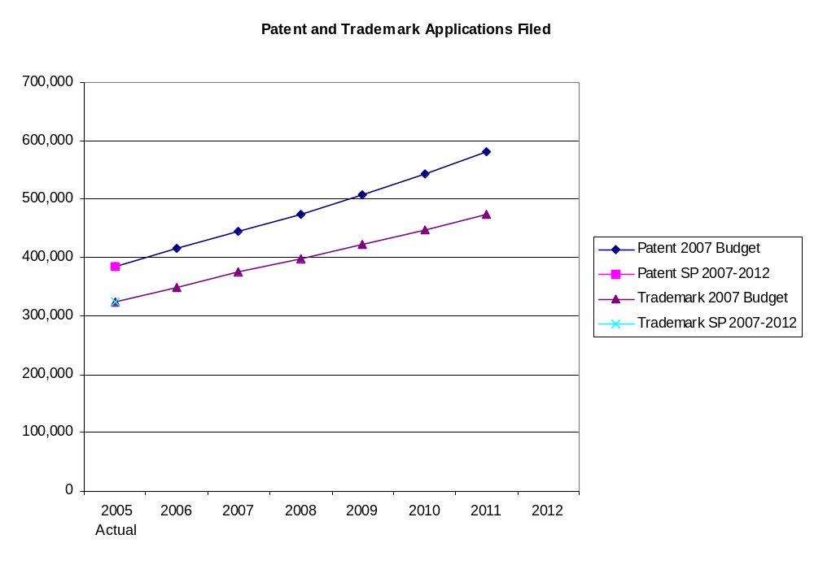
Note: SP 2007-2012 projections to be inserted.

GOAL 1: Optimize Patent Quality and Timeliness

Accomplishments for 2005/2006

- Hired 978 patent examiners in 2005 and are on target to hiring 1,200 in 2006 to address the increasing backlog of unexamined applications.
- Developed an academy approach that intensifies the training to new patent examiners that is a major improvement over the traditional academy. New employees are given in-depth, basic training for up to one year that combines lectures, practical applications, small group study, and one-on-one on the spot assistance with real patent applications.
- Piloted a Patents’ hoteling program enabling patent examiners to access the systems they need to do their jobs from home, allowing the Office to expand the size of the Patent Examining Corps to address increased workloads.
- Developed a new pre-appeal brief conference pilot program enabling applicants to request a panel of examiners to formally review their application rejections before they file an appeal brief, thereby reducing the number of applications processed by the Board of Patent Appeals and Interferences (BPAI).
- All ex parte patent reexaminations pending for more than two years were processed to final determination. We continue to carefully track and provide the necessary resources to keep the process current.
- Launched a web-based patent application filing system that allows electronic filing of patent applications (including automated processing of images). Electronic filing prevents introduction of errors during processing. The processing is expedited because electronically filed documents are directly “soft scanned” into IFW thereby eliminating the indexing and scanning process time. Documents are immediately available to the examiner in IFW and to the applicant in the Patent Application Information and Retrieval (PAIR) system.

Introduction

The benefits of a patent system have been obvious to Americans since the founding of our country. More than 200 years ago, the need for a patent system was addressed in the Constitution, and a statutory system to examine and grant patents was put in place. Since that time, the ingenuity of American inventors, coupled with a patent system that encourages and rewards innovation, has transformed America into the world’s preeminent technological and economic nation.

Today economic success depends on intangible, information-based assets, and industries, such as biotechnology and computers, which now represent major sectors of the American economy. As the clearinghouse for U.S. patent rights, the USPTO is an important catalyst for U.S. economic growth. Through the prompt grant of patents, the USPTO promotes the economic vitality of American business, paving the way for investment, research, scientific development, and the commercialization of new inventions. The USPTO also promotes economic vitality by promptly assuring that only meritorious patent applications are allowed, thus providing certainty that enhances competition in the marketplace.

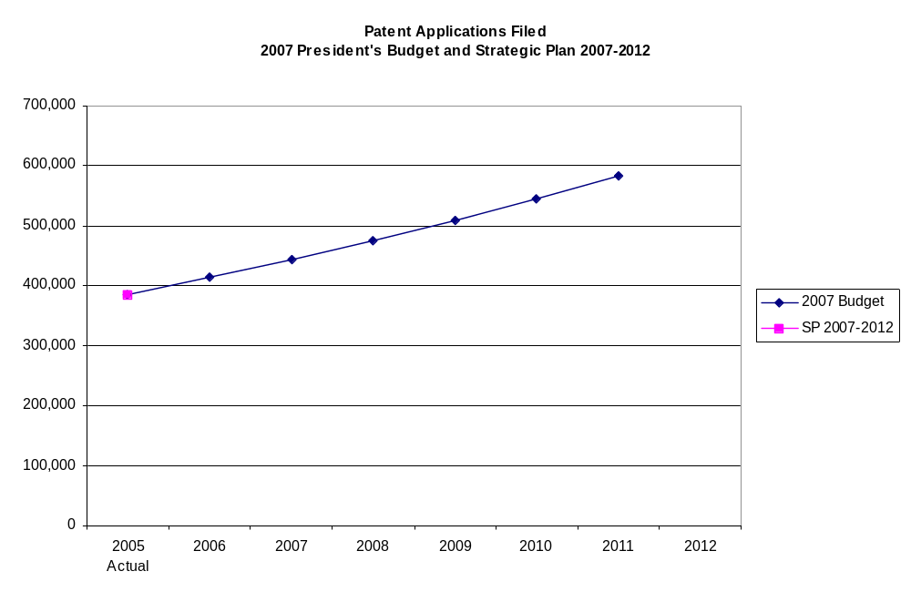Note: SP 2007-2012 projections to be inserted

Challenges/Opportunities

Although the goal of optimizing patent quality and timeliness seems concise and focused, it gives rise to a broad spectrum of challenges for its successful achievement. Attracting, hiring, training and retaining the high quality examiners who are critical to meeting this goal is a multi-faceted effort that includes the competition for some of the most talented and recruited individuals in tomorrow’s work force. Quality of the examination process requires a shared (between applicants and Office) understanding of what defines that quality and the level of finite resources that should be devoted to the process. Offering patent applicants a variety of products that fit their individual needs with respect to protecting their intellectual property rights while effectively and efficiently applying the resources of the USPTO is necessary to keep this the best patent examination system in the world. With the ever-expanding capabilities of our information technology, leveraging those advances in ways that are most productive for both the USPTO and the patent community requires a clear vision of the examination processes of tomorrow. To fulfill the objectives of the patent system, the USPTO must provide service to those who use the system and instill awareness of its potential value to the public at large.

In order for Americans to reap the benefits of their innovations, they often rely on the legal rights associated with a granted patent. This means that, the longer it takes for the USPTO to review a patent application, the longer it will take for an applicant to receive the patent rights to which they might be entitled. Congress and the public have recognized this issue – referred to as “pendency,” or the time an application remains with the USPTO until a final decision is made – as having a direct impact on American competitiveness. Congress and the public realize that one means of ensuring timely, high-quality review of patent applications is for the USPTO to hire and retain more patent examiners. Unfortunately, the call for more patent examiners comes at a time when American engineers and other scientists are in higher demand than ever.

Hiring Patent Examiners

Exacerbating the problem is our growing patent workload and the resulting need to attract and hire even larger numbers of new patent examiners. In FY 2006, the USPTO plans to hire 1,200 patent professionals, and in years FY 2007 – FY 2012, we plan to hire at least 1,000 a year, for a total of at least 7,200 patent examiner hires in 7 years. This level of hiring is a critical component of the plans to address patent pendency regardless of the time frame for such improvements. Notwithstanding these massive hiring efforts, in the absence of other changes to the current examination system only modest gains in reducing patent pendency are likely to be achieved in the near term. In fact, until these new hires are effectively absorbed into the examination system, average patent pendency will continue to increase.

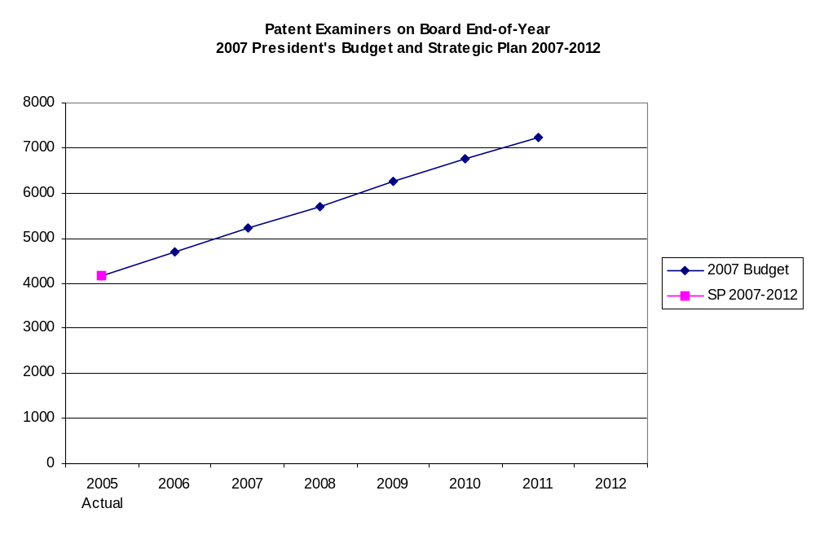
Note: SP 2007-2012 projections to be inserted

Training Patent Examiners

Inextricably intertwined with the need to hire more examiners are the needs to hire the individuals who will be able and motivated to produce high quality examination results and to train and retain these individuals to improve the quality of the examination process. With properly implemented hiring and training of new examiners, and training for the current examiner corps, substantially improving patent examination quality will be linked to reductions in patent application pendency. Examiners need to be able to make the right decisions, in most instances, the first time they perform the work, have the necessary job skills for that purpose and have the proper incentives to promote that outcome.

Need for an Alternative Examination System

A critical challenge for the USPTO in achieving the most important objectives of patent examination quality and application pendency lies in addressing the constraints imposed by the very nature of the examination process. The current patent examination system in the United States is basically a one-size fits all process that culminates in the grant of a letters patent (with a statutory presumption of validity for all such granted patents) or the abandonment of the application, and ultimately the efforts by the applicant to seek protection. Although well over 400,000 applications will be filed this year, less than all will result in a patent grant and of those granted patents less than all will mature into a product that is ultimately brought into the marketplace, be licensed for use by others, or have ownership transferred to others for possible future exploitation. The current examination process imposes high demands for resources on the part of both the applicant and the USPTO. Further, the high demand for examination under this traditional process has exceeded the current abilities of the USPTO to examine applications as they are filed, resulting in an increasing backlog of unexamined applications. With the limited options for determining when examination is desired or advancing applicant’s position in the examination queue, some applicants are forced to pursue the examination process before they are ready to capitalize upon a successful result from the process while others in need of a rapid determination of their rights languish in the queue.

Not every patent applicant needs a final determination of the intellectual property rights to which they may be entitled. Some applicants need to secure potential funding to bring their inventions to the marketplace and an early determination of the rights that are available to them. Some applicants need the same early determination of rights due to the relatively shorter potential time frames for their inventions in a quickly changing marketplace. Other applicants need time to determine what are the best commercial alternatives to the myriad of ways their invention could be implemented. Some applicants want a very high level of assurance that the property rights that they obtain will likely withstand any future challenges and are willing to expend additional resources and efforts to help to ensure that outcome. Further, whereas some applicants need the results that today’s traditional examination process bring, other applicants may be willing to accept more limited property rights in exchange for lower costs and faster processing times.

An open question that the USPTO will address with its stakeholders and in conjunction with the Administration, the Congress and Trilateral partners is whether or not, as an alternative to the current examination system, there is some combination of examination processes and patent products that will better allow applicants to choose what determinations and results they need and what are the most efficient processes to pursue those results and at the same time provide a more efficient use of the examination resources of the USPTO by only providing the level of examination required by the applicant. The answer to that question is by no means certain. Applicant acceptance of the various options that could be developed, the ability to reach a consensus among the varied interests of the technology sectors, and the potential need for legislative changes represent a few of the significant barriers to this effort. The USPTO must also keep in mind the international requirement that our patent system must be free from discrimination. However, the potential gains for all users of the patent system are believed to far outweigh those obstacles. Applicants may achieve higher quality and more timely determinations of the potential patent rights that fit their specific objectives and be able to tailor the expenditure of their resources accordingly. These processing choices could also ensure that the USPTO minimizes patent term adjustments and provides products and services that continue to stimulate the U.S. and global economies.

Quality of the Examination Process

Patent quality is always a topic of debate. Universally acknowledged as an expected and required outcome from the examination process, its definition and current level have achieved far less consensus. That definition and current perception of quality have as many facets as the perspectives of those who characterize this desired result; including corporate executives, patent applicants and owners, competitors, prosecution practitioners, venture capitalists, litigation specialists, patent examiners, oversight bodies of the patent system, academics and the general public. Frequently characterized as an after-the-fact outcome following extensive and tortuous litigation and review of the patent grant, both in the courts of law and public opinion, it seems to have little relationship to the initial examination process and its finite scope. Thus, producing public confidence that patent grants are of the highest possible quality has been a most elusive target for the last several decades.

One of the most vexing problems in the area of assessing patent examination quality has been the wide-held belief that the current quality review measures of the USPTO inspire little confidence as to the accuracy and meaningfulness of the data and the propriety of any established performance targets. Additionally, whereas the primary quality measure of the USPTO, the allowed application error rate, has varied between 4 and 7 percent over more than a twenty year period, the perception of continuously improving quality has not been achieved to date. The USPTO has undertaken numerous efforts to address these issues by expanding the data considered in this process and refining its assessment processes including introducing an in-process review component to the quality data, employing quality review results to guide the development of examiner training programs, looking at customer satisfaction data, using larger samples of data, using data more targeted to the individual examiner level and considering data from both the supervisory and quality assurance review processes. None of these efforts has achieved the desired results of continuously improving examination quality and increased public confidence in the USPTO quality measures.

Determining what should be the appropriate measures of patent quality and what should be the performance targets given the current initial examination process and levels of resource funding provided to support that process is of critical interest to both the USPTO and the patent community. The patent community could assist in developing an objective, to the maximum extent practical, set of review criteria that could be applied across all selected review processes to promote greater consistency and credibility for the measurements of quality. Further, this effort could determine what measures should be used to assess examination quality, how these measures should be reported and what meaningful quality targets should be the goals of an initial system of patent examination. A critical component in the process of determining these measures and targets would be achieving the proper balance between the desire for assured high quality results from and the inherent realities of the resource limitations and ambiguities of the initial examination process.

Awareness of Intellectual Property Rights

Intellectual property rights and their utilization in the global economy impact every American on a daily basis but are all too frequently not well understood by the general public. Increasing public awareness of various intellectual property issues and interests and how these affect them is an important aspect of the USPTO role. Educating the public about the examination processes of the USPTO and how these relate to the use of intellectual property rights in the marketplace would help in that process. Communicating to and informing the public about the intersection of IP issues and the news stories they read everyday would help to generate a better understanding of the role of such rights in the global economy. Promoting an understanding that the violation of intellectual property rights affects everyone, and how, would be beneficial to improving the effectiveness of the system as a whole.

In addition to the general goal of improving the current understanding of various intellectual property issues and interests, the USPTO has a specific role in providing assistance to the patent community that regularly uses its services. Outreach to individual inventors and inventor groups through regular regional programs to assist in the filing and prosecution of patent applications is critical to that effort. Ensuring that all affected applicants and others in the patent community have a seat at the table to discuss potential USPTO directions and operational issues would help to create the engagement that is important in reaching the most extensive consensus on the important issues of the day.

Information Technology

USPTO has been successful in employing information technology to assist in the examination process. For example, the USPTO has implemented the Patent Application Location and Monitoring system (PALM), the EAST and WEST search systems, the Patent Application Information and Retrieval (PAIR) system and the Image File Wrapper (IFW) application processing system. However, the USPTO faces several challenges and problems connected with the IFW application processing, the lifecycle of various documents, and the system interfaces with other USPTO information technology systems. Patent examination processing, examination workflow and application data storage is currently served and supported by IFW, which provides document images and limited workflow support through the messaging system. Application documents are filed electronically or scanned, and IFW messages are generated for applications and used to pass responsibility for examination tasks within and between business units. However, IFW messaging was not designed to manage workflow because there is no workflow business rules enforcement mechanism, timeout escalation reporting nor any historical tracking. As a consequence, examination tasks are frequently misrouted and not completed in a timely manner. This increases pendency and delays patent application publication and patent grant issuance and potentially leads to re-work that adversely impacts examination quality. IFW also does not provide support identifying and eliminating bottlenecks and dead-ends in the examination processing, provide accountability of message processing by various personnel, or support overall data quality of the application files.

The transition to a new fully-tagged text based patent application processing system offers the combination of potential benefits and challenges in determining the best implementation to leverage the functionality of this new information technology resource. Determining the best methodology to support remote access to patent information will be critical to this effort. The potential to increase the productivity of examiners through seamless access to examination tools may be possible. Providing full workflow management functionality for better control of documents to improve product quality and ensure proper processing, escalation of delayed and late tasks and audit reporting, and historical tracking of the examination process could be achieved in this implementation. Further, potential gains could be made in reducing the remaining labor intensive paper-based processing, supporting the hoteling initiative, collaborating and partnering with other international Intellectual Property Offices and instituting an efficient interface to existing USPTO systems. The collective effect of these improvements would provide an efficient examination process and the examination support to allow the USPTO’s workforce to meet the demands of working in a global intellectual property system.

In addition to the potential benefits that could be achieved with respect to the workflow processes and document management aspects of processing patent applications, the new Patent File Wrapper (PFW) implementation could provide for other advantages for both the USPTO and applicants and their representatives. The use of the same information and access tools may also offer possibilities for “real-time” changes to the patent application without the need for intervening USPTO processing time. This capability would support push-button publication and continuous access to the current content of the application. Filing options for all applicant submissions could be more flexible compared to the rigid requirements of the current IFW system. There is the potential to provide for both some pre-examination and examination processing of the application as filed, saving prosecution efforts for both the USPTO and the applicants. Further, this new system could provide the capability of a single docketing system for both the USPTO and applicants wherein both parties to the patent examination process work from the same information and use the same access tools and interfaces.

The challenges presented to the USPTO are both significant and wide-ranging. Clearly, the USPTO needs to hire more examiners, improve quality of the examination process, offer products and services that best meet the needs of patent community and the public, leverage the possibilities of the new information technologies and enhance the awareness of the importance and impact of intellectual property rights. Many of these challenges require interrelated considerations in addressing the same. Our strategic plan provides a set of focused initiatives that should produce, or at least start the necessary processes to ultimately produce, solutions to the opportunities and challenges set forth above.

Strategic Response

Objective #1: Provide high quality traditional examination of patent applications leading to final disposal of most applications in XX months by 2012.

Strategy: Hire more patent examiners, train and retain them more effectively, and send them home or to alternative Government sites to work.

Initiatives
- Enhance Recruitment to hire 1,000 new examiners a year for an extended period of time, including examiners with degrees in emerging technology areas. (PAT 1 and 2)
- Establish Regional USPTO offices. (PAT 3 and 4)
- Enhance Training. (PAT 5)
- Create Partnerships with Universities. (PAT 6)
- Establish a Retention Bonus Program. (PAT 7)
- Establish Flat Goal, Piecework and awards above 100 Percent. (PAT 8)

Planned Accomplishments/Results
- Pendency time will be reduced to xx months in 2008 and to XX months in 2012.
- Backlogs of unexamined cases will be reduced by XX percent a year.
- Meet hiring target of 1,000 examiner hires a year through FY 2012.
- Provide agency with great flexibility in meeting space and hiring needs.
- Optimize production capacity of examiners.
- Improve retention and training of examiners.
- Successfully negotiate flat goal/awards.

Strategy: Improve and enhance examination efficiency and effectiveness.

Initiatives
- Improve Search Quality by improving the examiners’ ability to locate the best prior art in the examination process. (PAT 9)
- Provide an Assessment on the Quality of Reviewing Applications. (PAT 10)
- Create a Stand-Alone Quality Award for Examiners. (PAT 11)
- Provide for Targeted Reviews in Problem Areas. (PAT 12)
- Develop Quality Metrics and Performance Targets with External Stakeholders. (PAT 13)
- Enhance the Skill Sets of Examiners Authorized to Train Other Examiners. (PAT 14)
- Patent Application Peer Review Pilot – Develop a peer review mechanism in which public sector volunteer experts will review published applications and provide prior art. (PAT (15)
- Conduct an External Validation of Office of Patent Quality Assurance (OPQA) Data. (PAT 16)
- Transition to an International Patent Classification (IPC) and Provide Support for the Necessary Reclassification Efforts. (PAT 17 and 18)
- Support Outsourcing PCT Chapter I Applications. (PAT 19)
- Develop Open Source Software Database to provide examiners with potential prior art. (PAT 20)
- Implement Examination Reform. (PAT 21 to 25)

Planned Accomplishments/Results
- Patent allowance error rate will be reduced to XX percent in 2008 and XX percent in 2012.
- Patent in-process examination compliance rate will increase to XX percent in 2008 and XX percent in 2012.
- Develop quality metrics and performance targets that increase public confidence.
- Implement rule changes (NPRs planned and proposed).
- Provide timely determination of inventor rights for both inventors and the public.
- Produce timely and high quality actions and avoid rework.
- Enhance the ability to get the “best prior art”.
- Combine efforts of the examiner and applicant to complete examination process with quality results.
- Outsource up to 20,000 PCT applications per year.

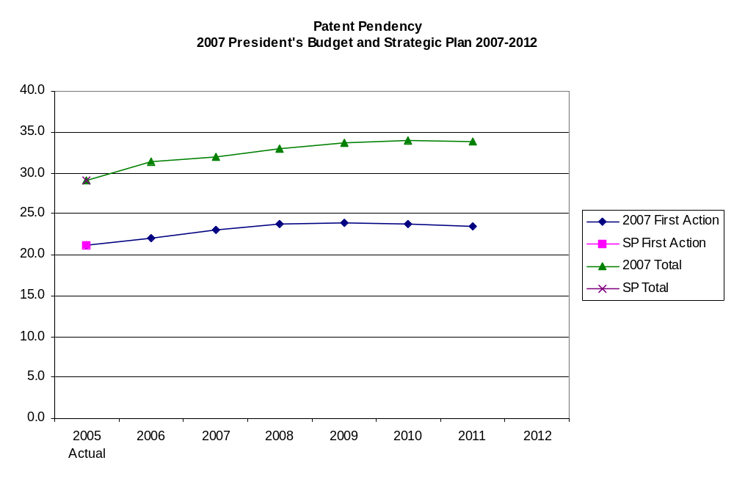

Note: SP 2007-2012 projections to be inserted.

Objective #2: Improve quality and timeliness of patent examination by developing a Patent suite of products.

Strategy: Offer alternative products and thereby move away from the current one-size fits all filing and examining system.

Initiatives
- Develop a Suite of Patent Products in Collaboration with Stakeholders. (PAT 26)

Planned Accomplishments/Results
- Deploy products that allow applicants to choose a patent product based on applicants’ need.
- Make more efficient use of USPTO examination and applicant resources.
- Promote efforts at Trilateral Offices for work sharing.

Objective #3: Improve and integrate existing electronic systems to promote full electronic patent application processing; implement better/more secure systems.

Strategy: Promote the utilization of electronic text content to facilitate the examination process and increase user acceptance of electronic filing systems.

Initiatives
- Implement the Patent File Wrapper. (PAT 27)
- Create a Centralized On-Line Docketing System. (PAT 28)
- Develop an Auto Office Action Generator Using Natural Language Processing. (PAT 29)
- Initiate a Search Exploration Project. (PAT 30)
- Increase E-Filing Initiative. (PAT 31)

Planned Accomplishments/Results
- Patent applications filed electronically will increase to 30 percent in 2008 and to XX percent in 2012.
- Patent applications managed electronically will increase to 99.0 percent in 2008 and XX percent in 2012.
- Enhance application text search and manipulation.
- Improved search tools for applicants and examiners.
- Improved data security.

Objective #4: Transform appeals processing, and enrollment and discipline functions.

Strategy: Become a more responsive organization and effectively administer post-grant review if enacted, and enhance communication and involvement with registered patent practitioners.

Initiatives
- Improve the Board of Patent Appeals and Interferences’ (BPAI) Flexibility and Accountability. (GC 1)
- Enhance Registered Practitioner Requirements. (GC 2)

Planned Accomplishments/Results
- Minimize the impact of significant increase in workload on current pendency goals.
- Improve inputs to application process through assuring currency, two-way communication with patent practitioners.

GOAL 2: Optimize Trademark Quality and Timeliness

Accomplishments for 2005/2006

- Improved accessibility to the trademark system by continuing to enhance Trademark electronic filing by expanding the number and type of transactions that can be completed on-line. More than 90 percent of initial applications and most subsequent documents are filed electronically.
- Established fee options to encourage greater participation in the U.S. trademark system – with higher fees for filing on paper, and lower fees for filing electronically.
- Made significant progress in achieving electronic workflow and file management; trademark data and images submitted through electronic forms or captured from paper documents are used to support examination, public documents, and issue trademark registration. All trademark examination is conducted directly from electronic records, eliminating manual paper-based processes altogether.
- The complete contents of the official trademark application and most registered files are now accessible on-line.
- Expanded the Trademark work-at-home hoteling program to include 69 percent of eligible examining attorneys.
- Thus far in FY 2006, reduced first action and disposal pendency times by more than one month each compared to FY 2005 actuals.
- Improved quality this fiscal year by reducing the final action deficiency rate by 1.4% compared to end of year 2005.

Introduction

American businesses derive a number of valuable benefits through the services provided by the Trademark Organization. At the USPTO website, a business thinking about adopting a new mark to identify its goods or services can readily search and discover more than two million marks in which others claim rights. The ability to conduct that type of search helps avoid expensive litigation. In addition, a business that registers its mark with the USPTO gains a number of procedural advantages from registration. The registration serves as prima facie evidence of ownership and the right to use the mark. The registration can be deposited with Customs in order to stop the importation of infringing goods and provide access to the federal court system. However, most importantly, the registration serves as notice to the world of the owner’s claim of right in the trademark.

Challenges/Opportunities

- Ability to provide certainty for first action pendency regardless of fluctuations in filing and funding. The lack of certainty for predicting filings in the short run and the volatility of trademark application filings, coupled with annual budgeting that begins 18 months prior to the start of a fiscal year, make it all but impossible to ensure consistent pendency under our present model for staffing and distributing work. We cannot assure less than 4 month first action pendency without changes in how we manage work absent greater assurance over workload and funding authority.

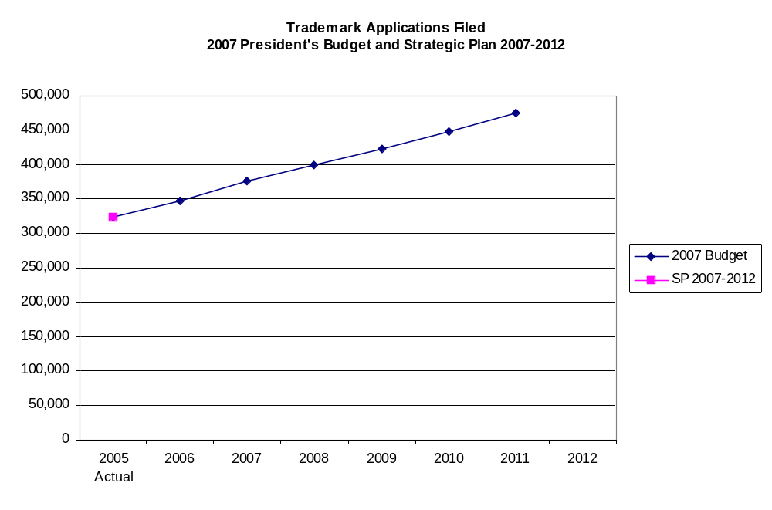
Note: SP 2007-2012 projections to be inserted.

- Work with the Administration to identify options for securing long-term funding stability and flexibility to adjust fees in order to create a predictable and orderly operating environment for providing certainty for applicants with the ability to make and carry out cost-effective investment decisions.
- Maintain quality as a highest priority and demonstrate quality examination through the identification of what constitutes quality and improved metrics.
- Accessibility to robust Trademark electronic workplace systems, which are adaptable to continuous improvement.
- Integration of Trademark and Trademark Trial and Appeal Board (TTAB) systems to provide a seamless interface for applicants and reliability of operations.
- Increased pendency for requests for reconsideration that are filed contemporaneously with the notices of appeal.
- Uncontrolled discovery along with an excessive number of discovery and trial motions increase the pendency of TTAB opposition proceedings and, ultimately registration or disposal pendency.

Strategic Response

Objective #1: Achieve and maintain a three-month first action pendency, and reduce disposal pendency excluding suspended and inter partes cases.

Strategy: Develop alternatives for predicting workloads, processing and managing the workforce and assigning work, reduce post-examination time by consolidating or eliminating redundant functions, and attract, hire and retain a highly qualified workforce.

Initiatives
- Achieve and maintain first action pendency goal of three months by actively managing the assignment of work based on total available production capacity each month. Pendency to registration or abandonment would increase if total staffing and funding were insufficient to maintain both pendency levels. All applicants would benefit from the certainty of faster and more predictable time for the initial examination. Applicants with an interest in obtaining registration would have an incentive to respond sooner to office actions. By managing total inventory relative to production capacity, fluctuations in disposal pendency would ensure that staffing does not outpace the level of filings. (TM 1)

- Disposal pendency can also be improved in a number of ways. The review process after approval for publication will be redesigned so that the approved file is reviewed immediately following approval by the examining attorney, the review is completed quickly and, when corrections are needed, the file is routed, corrected and returned to the publication queue as quickly as possible. Additionally, the USPTO is in consultation with the Government Printing Office (GPO) to compress the schedule for printing the Official Gazette. The potential exists to reduce several weeks of time in the post publication process that will translate directly into improved final action pendency. (TM 2-5)

- Transfer most of the examination of statements of use to Trademark Specialists. Examining attorneys would only handle statements of use when a substantive issue is raised. This would allow examining attorneys to focus more time on other examination.

- Expand the successful work at home program and continue to hire and train new examining attorneys in order to create a work force that can maintain first and final action pendency at agreed upon goals. The size of the Trademark examining attorney staff will stabilize at about 438 examining attorneys in FY 2008. After that, hiring will be mostly to replace attritions until 2010. Current plans show the Office reaching three-month pendency at the end of fiscal year 2008 and maintaining that pendency. (TM 6 and 7)

Planned Accomplishments/Results
- First Action pendency will be reduced to 3 months in 2008 and be maintained in the 3–4 month range from that time forward.
- Reduce final pendency by at least one month by 2008.

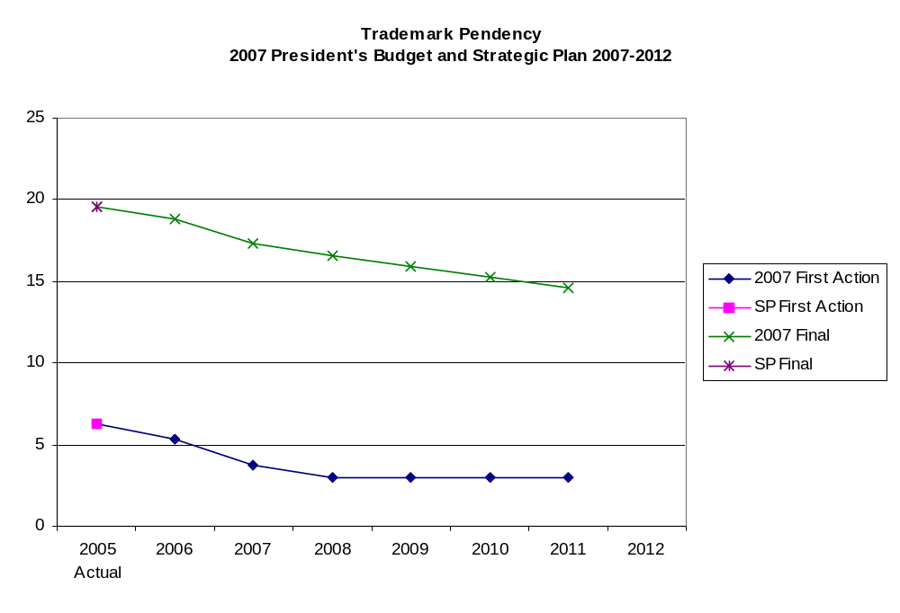
Note: SP 2007-2012 projections to be inserted.

Strategy: Reduce the number of appeals filed with TTAB and reduce the overall pendency of TTAB opposition and cancellation proceedings.

Initiatives
- Implement TTAB Case Resolution. (GC 3)

Planned Accomplishments:
- Reduce the average pendency of contested trademark oppositions by at least two months by FY 2008 and achieve continued reductions in average pendency in subsequent years.

Objective #2: Improve quality of examination by ensuring consistency and quality of searching and examination and provide internal on-line tools.

Strategy –Expand the current standard for quality review, apply to all aspects of examination and processing, and capture the results for evaluation.

Initiatives
- Continue quality improvements that began with the adoption of a new quality standard and quality review process in FY 2003. There has been a measurable improvement in examination quality as measured by deficiencies or errors. In FY 2004 the first action deficiency rate was 7.9% and the final action deficiency rate was 5.8%. In comparison, in fiscal year 2005, the first action deficiency rate was 4.7% and the final action deficiency rate was 5.9%. By the end of FY 2005, examiner performance was evaluated based on quality review results.

In FY 2007, add more than 8,000 quality review results per year to those considered by piloting manager and senior reviews of examining attorney work to the evaluation process. This project should, over time, improve the consistency of examination by identifying potential problems from errors that can be addressed through improved guidance and retraining.

Create and update manuals and work steps for all examination support functions. Manuals and work steps will become accessible through the comprehensive process map that is being developed to document the flow of work through the trademark process, from receipt through to post registration. Additionally, process “owners” will ensure that the work steps and manuals are kept current. The process map will provide a workflow timeline to better indicate the status of every application or registration and better support a diverse staff and applicant base.

Reassess functions and procedures as a result of the implementation of electronic workflow and file management, which will eventually create on-line dockets that will permit closer tracking, assignment and monitoring of work. An assessment of the work procedures and standards is under way to ensure that the work is evaluated and quality measures are established that will more accurately reflect the quality of the work done by legal instrument examiners (LIE’s), trademark specialists and other technical staff. Performance plans will be revised to reflect quality and performance measures.

Pilot and implement a more thorough measure for assessing the quality of the final-work product. At the present time the “final action” quality measure reviews only applications that are being refused registration. The review does not include applications that are approved for publication—the bulk of the work done by examining attorneys and arguably the work-product that trademark owners care most about. Trademarks will pilot this new measure in 2007 and adopt it for use as an Agency measure in 2008. (TM 8-10)

Planned Accomplishments/Results
- Pilot a new final-work quality measure in FY 2007 and, based on the results of the pilot, set target goals for the new final work quality measure in FY 2008.
- Reduce the first action deficiency rate to 5.5% in FY 2008 and 4.7% in FY 2012

Objective #3: Provide electronic file management and workflow by the end of FY 2009.

Strategy – Using lessons learned from the Trademark workflow process mapping done in 2006 and 2007, complete the implementation of the electronic workflow and file management system by the end of FY 2009 for trademark specialists and legal instrument examiners. The system will allow a more efficient design and control of the work process, provide tools to monitor and better manage the work, measure production and timeliness and evaluate quality.

Initiatives
- Expand the electronic file management and workflow system in FY 2007 to include the law offices, and the intent-to-use and the publication and issue processes. In FY 2008, electronic file management will be implemented in Post Registration and in 2009 expanded to the petitions process, the Trademark Assistance Center and Pre-Examination. Continuing expansion of electronic file management, when combined with internal process mapping, will allow the Office to create a more efficient process by eliminating redundant work steps. Electronic workflow combined with process mapping will provide visibility that will give greater certainty and better control over quality.

Integrate existing electronic systems and make better use of sharing applicant data internally. For applicants who request electronic communication, the notification process will be improved by sending e-mail links to the applicant or registrant rather than e-mailing the Office action. This change should end the problems caused when customer e-mail programs refuse e-mails with large attachments or prevent receipt because they are not within acceptable parameters. (TM 11)

Planned Accomplishments/Results
- Complete documentation of process maps and procedures manuals; identify opportunities for process improvement, staffing, production and quality standards – September 2008.
- Make process maps available electronically for internal and external use to provide access to file status and certainty of processing time by September 2009.
- Develop and maintain one central location where all examination guides and resources can be electronically accessed to improve consistency and support a diverse and remote workforce by September 2009.

Objective #4: Develop interactive on-line electronic filing capabilities by 2010 and upgrade e-tools.

Strategy: Upgrade search tools both on-line and internally to improve the ability to identify generic and descriptive terms, and replace some of the Trademark Electronic Application System (TEAS) current function with an on-line docket system that allows applicants and their representatives to amend their applications, respond to Office actions and otherwise make appropriate changes in applications and registrations. The docket system would give automatic notice of upcoming events in the life of an application or registration e.g. a section 8 affidavit is due.

Initiatives
- Upgrade search tools to improve not only searches for confusing similarity but also to improve the examining attorneys’ ability to identify descriptive and generic works. Existing quality review data will be used to identify current and upcoming descriptive terms for each class of goods and services. (TM 12)

- Begin designing the next generation of TEAS. Although the current system has been most successful, new technologies, and increased expectations among customers as to how web sites should collect and maintain information, provide an opportunity to improve what was first designed more than seven years ago. The next generation of TEAS will provide inexperienced filers with more help and allow experienced filers to proceed quickly through the application and registration process. Future improvements will incorporate process efficiencies by automating the receipt and collection of data between existing systems.

- By 2010, TEAS will move beyond electronic filing as the Office begins planning an on-line docket management system that can be used by attorneys and applicants to view and submit changes to application and registration files. Applicants, registrants and their attorneys will have customer accounts that permit them to view their docket of cases, receive e-mail notification of upcoming deadlines, and feature real time updating of the USPTO application and registration files. (TM 13)

Planned Accomplishments/Results
- Begin planning for an on-line external docket management system in 2010 to permit applicants to manage and revise pending applications.
- Create a data-mining tool to improve search results for common descriptive language by industry.
- Automate the receipt, transfer data, update status, and transactions for filing existing TEAS forms, incorporate automated receipt and processing in future design and requirements by December 2007; incorporate efficiencies in process.
- Complete design for the second-generation approach for Trademark/Servicemark Application, Principal Register, by December 2007.
- Deploy the first second-generation form by end of FY 2008.
- Continue transformation of other forms to the second-generation approach, with completion of re-design for all existing forms by FY 2010.

GOAL 3: Improve Intellectual Property Protection and Enforcement Domestically and Abroad

Accomplishments for 2005/2006

- Initiated the placement of USPTO IPR experts in Brazil, China, India, Russia and other developing regions.
- Contributed to the shared goal of fighting piracy and counterfeiting under the Administration’s Strategy Targeting Organized Piracy! (STOP!) initiative.
- Assisted in developing the U.S. government position in MGM v. Grokster, a Supreme Court case involving the infringement of copyrighted works over peer-to-peer file sharing networks.
- Established the USPTO Global Intellectual Property Academy (GIPA) to expand IP training programs for foreign government officials.
- Collaborated with our counterparts in the Chinese government to improve China’s IPRs administration and enforcement.
- Provided negotiating support and IPR expertise for all Administration international and domestic IP policy and legislative matters.
- Provided substantive and negotiating support to the USTR for the IP chapter for all FTAs
- Provided technical and policy advice in the Special 301 process bilateral IP discussions and technical assistance.
- Provided small business outreach focusing on IPR and enforcement of rights in the global marketplace and conducted China-specific programs
- Implemented a trial Patent Prosecution Highway program electronic file wrapper access and electronic priority document exchange through the USPTO Trilateral Cooperation with Japan and Europe.
- Continued to pursue patent law harmonization through the “Alexandria” Group and outreach with private sector stakeholders.
- Revitalized the Patent Cooperation Treaty (PCT) Meetings of International Authorities process to reap the potential harmonizing effect of refined and revised PCT search and examination guidelines.
- Held discussions with various National IP Offices regarding exchange of search and examination results and the possibility of performing search and examination services for the USPTO for applications filed under the PCT.
- Entered into agreement with the Korean Intellectual Property Office (KIPO) to perform search and examination services for the USPTO for applications filed under PCT.
- Negotiated and adopted the Singapore Treaty on the Law of Trademarks in Singapore, on March 28, 2006.
- Increased the number of BPAI decisions designated as precedential.

Introduction

One of the tenets of the American Competitiveness Initiative is to foster a business environment that encourages entrepreneurship and protects intellectual property. “The American Competitiveness Initiative supports an efficient system that leads the world in the protection of intellectual property resulting from public and private sector investments in research”. The USPTO is an important component in the Administration’s strategy to encourage American innovation and strengthen the nation’s ability to compete in the global economy. America’s economic strength and global leadership depend on continued innovation. It is the responsibility of the USPTO to ensure that US intellectual property systems are continually strengthened to meet the needs resulting from technological advancements, promote the intellectual property system of the United States, ensure that foreign intellectual property offices are similarly focused, and assist in protecting the IP rights of U.S. interests abroad.

To keep competitive in an increasingly globalized business environment, U.S. businesses need as much certainty as possible in the creation and protection of their intellectual property, both here and abroad. Losses due to counterfeiting and piracy seriously undermine U.S. businesses’ ability to trade globally. Additionally, the costs and difficulties in obtaining IP protection globally and preserving and enforcing these rights is an impediment for many businesses.

We believe that the attributes of quality, certainty, cost-effectiveness, accessibility, and effectiveness are universally applicable to legal systems, examination systems, and any international framework dedicated to the protection and promotion of intellectual property rights. The USPTO will continue to work diligently to ensure that America has the best IP system and to improve IP practices worldwide.

In a period of flux in the development of IP law, the USPTO will be challenged to provide leadership. The Office will assist the Solicitor General of the United States in cases before the Supreme Court, particularly as the Count considers the development that has occurred in jurisprudence of the obviousness standard in patent law, and play a crucial role in providing guidance for best practices in patent examination.

In its role as policy advisor on IP matters, the USPTO will continue to promote policies that enhance competitiveness for US businesses abroad. The USPTO also will continue to advocate policies to streamline obtaining IP protection in various countries and negotiate agreements to strengthen the protection of US interests abroad. The USPTO furthermore will expand its assistance to innovators and businesses on how to obtain, protect and enforce IP rights in other countries and assist with dispute resolution when problems occur.

Challenges/Opportunities

- Lack of streamlined international IP systems makes it difficult, slow, and expensive for innovators and businesses to obtain protection in all of the necessary markets around the world.
- International anti-IPR movement is opposing international standards and working to roll back existing IPR standards for protection.
- Lack of unity among pro-IP nations may allow anti-IP forces to exploit relationships to the detriment of the public worldwide.
- Counterfeiting, piracy and failure to respect IPRs undermine conditions for US economic growth and competitiveness.
- The TTAB and BPAI need to enhance their functions by providing greater guidance to the examination process and greater input into the development of patent and trademark law.
- Small inventors may be discouraged from use of the patent system, either by the cost of hiring attorneys to prosecute applications or by disappointment in the services of companies that undertake to promote their inventions.
- There needs to be better coordination of USPTO outreach programs, particularly planning programs in a strategic and synergistic manner.

Strategic Response

Objective #1: Support efforts and initiatives aimed at strengthening intellectual property protection and curbing theft of intellectual property.

Strategy: Increase our presence and activities domestically and internationally to advocate U.S. Government IP policy so that U.S. businesses and innovators can better secure and enforce their IP rights.

Initiatives
- Expand Foreign Postings of IP Experts. (EA 1)
- Expand Global Intellectual Property Academy (GIPA). (EA 2)
- Expand Training and Capacity Building. (EA 3)
- Negotiate and Implement IPR Chapters of Free Trade Agreements. (EA 4)

Planned Accomplishments/Results
- Strategies developed for addressing counterfeiting and piracy issues by country and region.
- Improved level of expertise on IP and enforcement for foreign prosecutors, judges, and IP administrators and examiners.
- Infrastructure developed related to IPR for obtaining and enforcing IP rights.
- Improved public access to information on protecting IP rights globally.
- Strengthened IP protection of U.S. interests abroad.

Expand Foreign Postings of Intellectual Property Experts

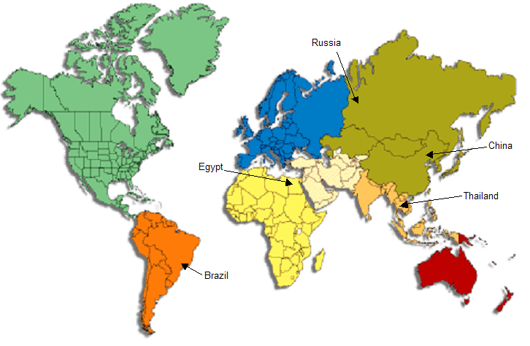

Objective # 2: Continue efforts to develop unified standards for international IP practice.

Strategy: Advocate progress toward global harmonization of IP, recognizing that many U.S. applicants conduct their businesses in a global environment.

Initiatives
- Advocate Progress in IP-Related Norm Setting Bodies. (EA 5)
- Develop Guidance for Electronic Filing and Processing. (EA 6)

Planned Accomplishments/Results
- Advocate progress on reduced package for patent law harmonization. Conclude and implement an international agreement possibly through a diplomatic conference.
- Advance Patent Cooperation Treaty (PCT) reform proposals to include searching standards, quality templates, and search and examination guidelines.
- Disseminate information on proposed improvements to the Madrid system.
- Increase electronic processing efficiencies in the U.S. and abroad.
- Reduce redundancies among IP Offices.
- Work toward harmonization of the treatment of geographical indications.

Objective #3: Provide policy guidance on all domestic IP issues.

Strategy: Promote domestic policies that advance the effectiveness of IP.

Initiatives
- Develop Domestic IP Reform Proposals. (EA 7)

Planned Accomplishments/Results
- Advance the Domestic and International IP policy initiatives of the Administration by:
- Establishing patent, copyright, trademark and enforcement reform focus groups to address other domestic policy issues to incorporate the principles of certainty, cost efficiency, accessibility, and quality through legislative and rule.
- Developing positions and proposals for specific patent reform proposals to promote and enhance patent protection.
- Developing and advancing legislation to implement patent law harmonization Treaty, and the Broadcasting Treaty.

Strategy: Increase the certainty and effectiveness of IP rights through development in decisional law.

Initiative
- Maximize Best Practices from Board Decisions. (GC 4)

Planned Accomplishments/Results
- Issue BPAI decisions that will promote clarity in the law - FY2007-FY2012
- Achieve and maintain an enhanced level of TTAB precedential decisions (60-80 per year) - FY2007-FY2012
- Citation of non-precedential decisions in briefs filed will be permitted no later than FY 2007, with use of those citations to identify needs for precedential decisions beginning in FY 2008

Initiative
- Provide Support to Congressional Personnel in Crafting Post-Grant Review Legislation.
(GC 5)

Planned Accomplishments/Results
- Improved patent quality.
- Increased efficiency in inter partes disputes on patent validity and reduction in patent litigation as the Office provides a forum for challenging patentability of patent claims.

Objective #4: Foster innovation and competitiveness by delivering IP information and education worldwide, and providing effective customer experiences in obtaining USPTO services.

Strategy: Leverage USPTO’s patent, trademark, copyright and enforcement expertise to ensure Americans benefit from the effective use of intellectual property.

Initiative
- Promote the Importance of IP Through Community Outreach and Public Awareness. (DIR 1)

Planned Accomplishments/Results
- Expanded USPTO’s role as IP leader.
- Increased familiarity of the public with IP resources available through the USPTO.
- China road shows conducted.
- Intellectual Property Awareness Campaign (IPAC) events successfully conducted.
- Increased information provided to the general public on global IP and trade issues.
- Expanded awareness on scam prevention.
- Increased knowledge of science and technology at educational facilities.
- Legislative and rule changes would address accessibility and add clarity to a process that is not easily administered by the Office or well understood to those outside the legal IP profession.
- By 2008, the office will offer script suggestions to the USPTO’s main call center, which will help USPTO better “triage” incoming calls.

MANAGEMENT GOAL

Achieve Organizational Excellence by:
- Enhancing a culture of high performance and becoming the employer-of-choice
- Ensuring responsible management of resources

Accomplishments 2005/2006

- Received an unqualified audit opinion on our annual financial statements for the 13th consecutive year.
- The Fee Modernization Act of 2005 was enacted, generating funds needed to meet the goals of high quality and timely issuance of patents and registration of trademarks, electronic government and work sharing.
- Received the “Certificate of Excellence in Accountability Reporting Award” from the Association of Government Accountants for the fourth consecutive year.
- In July 2005, the USPTO completed its relocation into new, consolidated headquarters in Alexandria, VA.
- In July 2006, the USPTO acquired new space to support two Patent Training Academy facilities for patent examiners.
- Established the first Human Capital Council to enhance the agency’s human capital management efforts.
- The USPTO continued to gain recognition as a leader in the Federal Government for its successful telecommuting programs.

Introduction

The USPTO has established a management goal that is applicable to all organizations within the Office. This goal focuses on the need to continually improve the organizational effectiveness of the USPTO to support accomplishment of its mission and strategic goals.

Through the agency’s Chief Financial Officer (CFO), Chief Administrative Officer (CAO), and Chief Information Officer (CIO), the USPTO:

- Provides timely and accurate financial management, procurement of goods and services, performance budgeting, and compliance with requirements mandated by the Congress, the Office of Management and Budget, the U.S. Department of the Treasury, and the Secretary of Commerce.

- Attracts, hires, trains and maintains a cadre of employees with knowledge and skills in an increasing range and depth of technologies.

- Provides the information technology that factors prominently in helping the USPTO achieve its mission and objectives.

Challenges/Opportunities

- Excellence in management can best be defined in terms of the business outcomes it produces -- outcomes such as improved business analysis, innovative solutions to business problems, reduced operating costs, increased capability to perform ad-hoc analyses, and improved overall business performance. As such we have identified several areas where improvement can have significant impact and added value to our external and internal customers.
  - USPTO systems need to be simplified and standardized, and be fully integrated to operate better and more efficiently.
  - Maintain automated financial and management reporting capabilities that provide managers with timely strategic information regarding the agency’s performance.
  - Maintain the integrated systems, data standards, and reconciliation processes to quickly and accurately report financial/management information.
  - Improve the expertise, relationships, and skills to lead and support enterprise initiatives such as improving cost efficiency and tooth-to-tail management.
  - Improve the financial rigor and reality we inject into the strategic planning process, effectively translate strategic plans into operational plans, and maintain planning processes that are efficient and timely.
  - Continuously maintain standardized processes and guidelines, as well as effective support capabilities, which ensure that unnecessary and costly complexity is forced out of the enterprise.
  - Establish structures and processes that allow USPTO to continuously hire highly qualified diverse personnel whose skills, knowledge and competencies match our mission-critical needs; improve retention of our qualified staff; and make significant investments in the people we hire.
  - Refine and improve performance management processes and systems to ensure that pay and award systems are aligned with performance.
  - Improve communication at all levels throughout USPTO.
  - Address the increasing and ever-evolving nature of the workload, work processes, and the work environment that pose tremendous challenges and problems for the IT organization.

Strategic Response

Objective #1: Function as a true business partner that achieves superior enterprise performance and provides strategic leadership.

Strategy: Take a leadership role in developing an enterprise-wide approach to provide reliable and consistent information for decision-making purposes.

Initiatives
- Develop a Dashboard that Displays Integrated Executive Management. (CFO 1)
- Develop Enterprise-Wide Management Analysis Expertise. (CFO 2)
- Take appropriate Steps to Utilizing Revenues Without Fiscal Year Limitations. (CFO 3)

Planned Accomplishments/Results
- Select performance measures that enable managers to effectively assess program results with a focus on outcome measures.
- Engage program managers in using data and targets to evaluate program performance, identify timely opportunities for improvement, and make decisions.
- Determine full cost of all critical USPTO programs.

Strategy: Recruit, hire, develop and retain employees with competencies for accomplishing our mission.

Initiatives
- Provide an Efficient and Effective Hiring System. (CAO 1)
- Enhance the Diversity of the USPTO Workforce. (CAO 2)
- Conduct analyses and offer a series of courses to develop skill sets for all employees. (CAO 3)
- Ensure that Managers and Supervisors Have Effective Tools to Manage. (CAO 4)
- Support Expansion of Telecommuting Flexibilities and Alternative Work Arrangements. (CAO 5)
- Develop a Sustainable Internal Communications Program. (CAO 6)
- Ensure Policies and Procedures Related to a Safe and Secure Workplace are Effective and Communicated. (CAO 7).
- Ensure that the USPTO Recognizes and Rewards High Performance. (CAO 8)

Planned Accomplishments/Results

- Maintain an optimum staffing level of highly skilled people.
- Increase employment in the under-represented groups in the agency’s workforce.
- Improve employee engagement.
- Provide work-life balance.
- Reduce attrition.
- Develop a better-trained and productive workforce.

Objective #2: Ensure operational excellence in enterprise-wide management processes.

Strategy: Enhance the capabilities of financial systems and processes.

Initiatives
- Establish an Enterprise-Wide Approach for Financial Management. (CFO 4)
- Establish Methods for More Accurate and Timely Predictions of Application Filings, Workloads, and Revenues. (CFO 5)
- Provide Full Self-Service Environment. (CFO 6)

Planned Accomplishments/Results
- Systems are integrated, data is standardized, and reconciliation processes are reduced/minimized.
- Reduce errors and processing times in credit card payments travel processing, and transit subsidies.
- Improve forecasting accuracy by up to three percentage points as a result of gaining access to additional data sets, expanded analysis, and working more closely with the business areas and external entities.

Strategy: Improve human resource processes and services.

Initiatives
- Ensure Compliance and Transparency in all Areas of HR Processes. (CAO 9)
- Establish HR Standards. (CAO 10)
- Leverage Integrated Information Technology in Streamlining the HR Processes. (CAO 11)
- Enhance the Competencies of HR Staff. (CAO 12)

Planned Accomplishments/Results
- Increase workforce knowledge in human resources policies and regulations.
- Increase customer satisfaction.
- Improve quality in HR transactions and decrease processing time.
- High performing HR operation.

Strategy: Improve the quality, cost-effectiveness, and timeliness of IT solutions.

Initiatives
- Simplify IT Systems and Support Infrastructure. (CIO 1)
- Improve Existing Business Area Tools and Capabilities. (CIO 2)

Planned Accomplishments/Results
- Naming conventions enforced enterprise-wide in all systems development efforts. Consistent naming across the enterprise.
- Enterprise data model in place to simplify and reduce our database environment.
- Governance framework instituted to ensure the integration of the Capital Planning and Investment Control (CPIC) processes with the Enterprise Architecture framework and process.
- Continuous monitoring program to maintain a system’s security posture during its life cycle and monitor compliance.
- Improved physical access of personnel to IT systems and data centers enhancing security.
- Collection, maintenance, dissemination, and use of information do not compromise the personal privacy of customers and employees.
- Digital Identity Management strategy in place, increasing security and integrity.
- Existing systems are fully documented and redesign migrations are mapped.
- Workflow tools are evaluated and most appropriate tool is selected for USPTO needs
- Agreements with other Intellectual Property Offices (IPOs) are in place – improved coordination.
- Improved search engines are in place which allow for: text, imaging, sequence, chemical
- PFW implemented.
- TM Systems Redesigned.

Objective #3: Dramatically simplify on-line access to, and availability of, USPTO information and data.

Strategy: Improve user friendliness of online products and services and patent and trademark search systems, provide direct, online access to uncertified copies of USPTO documents, and strive to develop and implement E-Government systems for filing and processing that are internationally compatible.

Initiatives
- Simplify Access to On-Line Data. (CIO 3)

Planned Accomplishments/Results
- Improved customer service.
- All appropriate USPTO electronic documents are electronically certified.
- Fully electronic assignment services are provided.
- On-line and bulk access data provided to the public in the most effective manner (allow data mining, accommodate individual users).
- Full document download of patents and patent application publications

Total pendency is the time an application remains with the USPTO until a final decision is made.
(Robert Shapiro and Kevin Hassett, “The Economic Value of Intellectual Property,” USA For Innovation Report, October 2005)
(Stephen E. Siwek, “Engines of Growth: Economic Contributions of the US Intellectual Property Industries,” Economists Inc. commissioned by NBC Universal, 2005)
Special 301 -- the identification of countries that deny adequate protection for IPR or deny fair and equitable market access for persons relying on IPR protection.

